Our 1st Grade Classroom News
The Week of Feb. 27– Mar. 3
Email: Lweeks@bluevalleyk12.org
Website: www.bluevalleyk12.org/hes/lweeks
Important Info

- We will be working on words that have silent letters in them this week (ex: know, wrap, gnat, lamb, climb).

- If anyone happens to go to Ikea and sees the $5 black stools (picture below), we could use a few in our classroom! 3 of my stools have broken this school year. I would love to get them replaced!
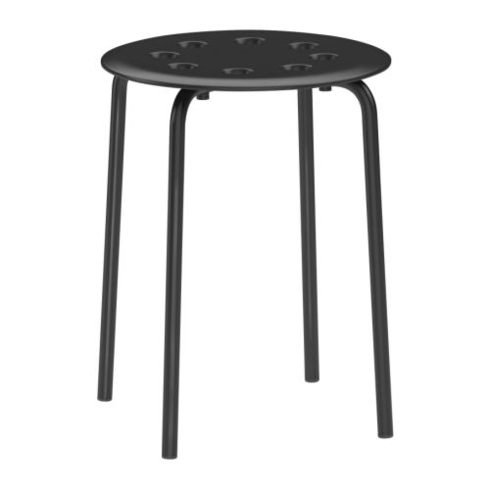
Website: http://www.ikea.com/us/en/catalog/products/10135659/

Upcoming Events

Math Challenge of the Week: We have been measuring things around our classroom using cubes and paperclips. If you have a ruler at home, have your child measure things around the house with it. Have them record the objects they measured and how many inches long they were (at least 5 objects). They can just do the nearest inch. For more of a challenge, have them do it to the nearest half inch or quarter inch.
Reading Challenge of the Week: We have been working on categorizing and classifying things while we read a book. For example, we read a book about penguins and it talked about the difference between hot and cold places. So we came up with a list of hot places we know of and a list of cold places that we know of. Have your child categorize and classify things they read about in a book!
Writing Challenge of the Week: Let your child free write for 15 minutes without stopping! You might even set up a timer for them. See what they come up with! Did they use periods? Did they use capitals? Did they add some descriptive words? Did they write at least 4 sentences? Did they use a beginning, middle, and end? By this time in 1st grade, the students should be doing all of these things on their own on a consistent basis.

March 1st Reading Charts Due
March 2nd Spring Pictures (individual and class pic)
March 10th – 20th NO SCHOOL
March 28th Early Release Day

Challenges of the Week

Website of the Week: THIS website is a great resource for grammar! It has TONS of games that have each of the grammar skills we work on in school! https://sites.google.com/site/easygrammar4kids/
App of the Week: Cramberry is an app where students can create their own flashcards to study different things. This could be used for phonics sounds, addition /subtraction/ multiplication facts, odd and even numbers, etc. Challenge your child to create their own flashcards over something they know a lot about for a sibling to do! This app is free!

Tech of the Week

